Coyotes Compete in First Indoor MTA Meet Held in Two Years – Feb 20, 2022

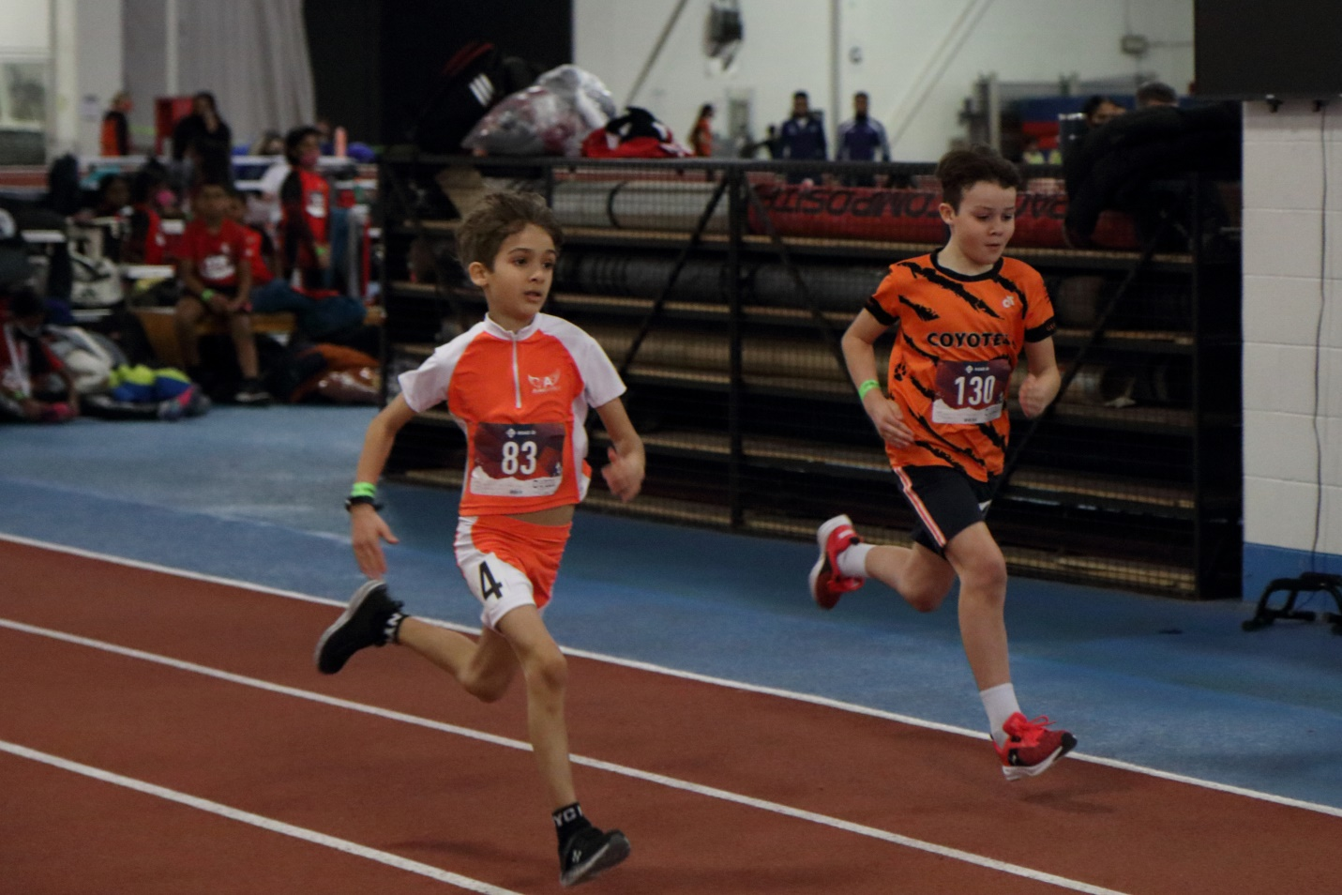
Photo: Meaford’s Joseph Spence, #130, in a sprint to the finish against one of Toronto’s Flying Angels in the first of his two races at the MTA Flying Angels Showcase

On Sunday, February 20, the Minor Track Association (MTA) hosted its first indoor track meet in two years’ time and the Georgian Bay Coyotes Track Club, based out of Meaford, were eager and excited to attend. With capacity limits still in effect and parents and athletes wanting to be cautious about attending an indoor race, the number of athletes was half of pre-pandemic levels with 247 athletes from 22 teams coming from throughout the province to compete at the Toronto Track and Field Centre.
The Georgian Bay Coyotes sent 9 athletes, six of whom have never had the opportunity to race at an indoor facility, to test out their winter training and see where they stand up against the province’s best. For those who are not aware, the Coyotes Track Club trains outdoor year-round despite the cold and snow and bitter temperatures and this was a great opportunity for the athletes to see the gains they’ve made this winter on some solid footing.
Athletes, parents and coaches started arriving at the track much earlier than usual but with delays caused by various reasons including entering into the building the event started well behind schedule. With many athletes getting to race for the first time and seasoned veterans itching to get back onto the track, there was definitely an air of excitement and nervousness throughout the building. Once the races finally got underway they certainly did not disappoint. Of the 18 races entered by the Georgian Bay Coyotes, 18 new or first-time personal best times were set.
The team brought home 5 medals and the crowds enjoyed some exceptional fourth-place finishes as well. The senior boys' 1500m was one of the highlights for the day as Coyote Emmett Leary started near the back of the pack and did some fancy passing to claw his way to the lead and then crossed the line in second place. Officials had to ask if he had completed all of his laps. The team’s youngest competitor, Joseph Spence, seemed to gain confidence as the day wore on, and he handily crossed the line in first place in the Tyke boys 1200m race. The Atom boys 800m race was a fun one to watch as it was full of Coyotes and Toronto's Flying Angels, which made for an entirely orange-clad group of runners. The two teams often duke it out, and today was no exception. The group stayed tightly knit the entire four laps and all five runners finished within 5 seconds of each other, with Carter Green taking second place, Jacob Martindill taking third and Nathan Leary taking fifth. There seemed to be a high level of competition in all of the girl’s races, and it was fantastic to see our Coyotes work hard to finish their races strongly.

Category | Name | Pos | Time | PB
400m
Tyke Boys | Joseph Spence | 4th | 1:20.19 | *
Atom Girls | Ella Kulakowsky | 4th | 1:18.33 | *
Atom Boys | Leo Elkins | 5th | 1:21.04 | *
Senior Girls | Isabel Spence | 6th | 1:16.08 | *

800m
Atom Girls | Ella Kulakowsky | 4th | 2:58.80 | *
Atom Boys | Carter Green | 2nd | 3:00.06 | *
Atom Boys | Jacob Martindill | 3rd | 3:01.32 | *
Atom Boys | Nathan Leary | 5th | 3:04.53 | *
Senior Girls | Olive Elkins | 10th | 3:01.30 | *
Senior Boys | Emmett Leary | 4th | 2:30.30 | *

1200m
Tyke Boys | Joseph Spence | 1st | 4:40.61 | *

1500m
Atom Boys | Jacob Martindill | 5th | 5:47.75 | *
Atom Boys | Nathan Leary | 6th | 6:05.38 | *
Senior Girls | Isabel Spence | 10th | 5:51.75 | *
Senior Girls | Olive Elkins | 12th | 6:25.04 | *
Senior Boys | Emmett Leary | 2nd | 4:54.01 | *

200m
Atom Boys | Carter Green | 3rd | 30.84 | *
Atom Boys | Leo Elkins | 11th | 36.25 | *

Coyotes Shine at 2022 MTA Provincial Indoor Track Championships – April 2/3, 2022
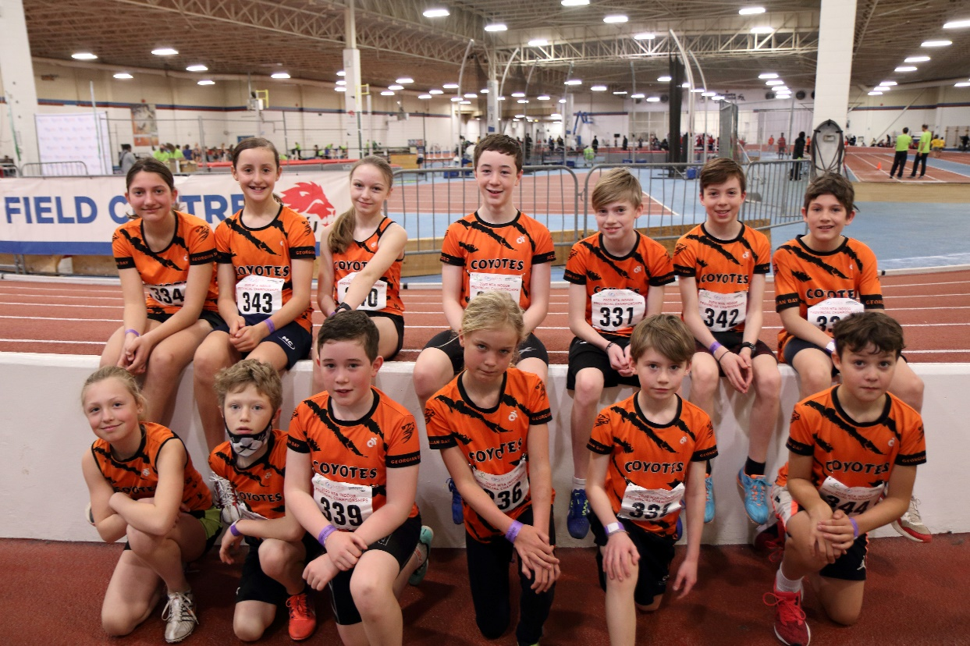
Photo: Members of the Georgian Bay Coyotes Track Club smile for pictures before the 800m races at the 2022 MTA Indoor Provincial Championships.
On April 2 and 3, the Toronto Track & Field Centre played host to the 2022 Minor Track Association Provincial Indoor Championships. Fourteen members of the Georgian Bay Coyotes Track Club were in attendance among the more than 540 registered athletes from across Ontario. The weekend was filled with fierce competition and resulted in some fantastic races. Once again, the Coyote athletes did themselves proud and came home with six medals and a dozen top 10 finishes.
Saturday started off with the 1200m and 1500m races and the Coyotes were out front early. Newcomer Alba Hargreaves was in the first race of the day; the Tyke girls 1200m race. She was calm on the line and when the starter’s gun fired, she was able to control her energy and excitement and took a place near the back of the pack. Over the next 6 laps of the 200m track she passed all the front runners winning her heat easily. After the final heat had crossed, she ended up placing a well-deserved 4th place overall. In the Tyke boys 1200m race two Coyotes, Joseph Spence and Liam MacInnes-Wiley were also able to run a very smart race, controlling their pace and finishing strong in 2nd and 3rd overall. This was the first individual Provincial Championship medal for both Coyotes. The older Coyotes then took to the track for the 1500m races and were well prepared for the competition. New personal best times were set by almost all the Coyote runners including Bryson Cleland and Nathan Leary in the Atom Boys category; Isabel Spence and Olive Elkins in the Senior Girls category, with Isabel dropping an impressive 12 seconds from her previous best time set only a month ago to 5:39.92; and Emmett Leary who dropped 9 seconds from his already impressive 1500m time to 4:44.97.
Saturday afternoon saw three Coyotes take to the track in the 400m sprints. Despite the Coyotes being known for their middle-distance speed they put on an impressive show in this very difficult sprint distance. In the 1st heat of the Mite boys 400m race, Coyote Caleb Cleland battled hard on the first lap of the two-lap race before easily taking the lead and winning his heat in an impressive time of 1:23.75. In the 2nd heat Tobin Goodman, also from the Georgian Bay Coyotes followed suit and led his heat from start to finish crossing in 1:24.97. After the times for the heats were combined Caleb & Tobin finished 1st and 2nd respectively, also winning their first individual Provincial Championship medals.
On Sunday, after some well-earned rest, the Coyotes were back on the track for the 800m races. The competition fields were deep in these races and the Coyotes managed to shine through again. Of the 13 Coyotes who toed the line on Sunday all 13 set new personal best times and with Caleb Cleland, Alba Hargreaves, Joseph Spence, Ella Kulakowsky, Bryson Cleland, Isabel Spence & Emmett Leary all winning their individual heats. Caleb Cleland ran a very impressive time in the Mite Boys 800m to take first and claim his second gold medal of the Championships. Joseph Spence managed to capture his second Silver medal of the Championships winning his heat but dropping a position to the winner of the final heat. In the Senior Girls 800m Isabel Spence was able to win her heat in one of the most exciting finishes of the day. In true Coyote fashion, Isabel was able to control the excitement of the start and settle into a quick pace at the back of the pack. Over the course of the 4-lap race, she managed to claw herself toward the front of the pack and on the last corner of the race one of her competitors used some dirty tactics to drive her to the very outside lane. Isabel managed to keep her composure and sprinted hard all the way to the finish along the outside line of the track.
Overall, it was a very exciting weekend with Coyotes setting new personal best times in 24 of the 26 races in which they entered. Their coach Steve Leary couldn’t be more proud of the athletes both for their running and how they represented the club and our community at the Championships. The Coyote Coaches received numerous comments and questions about where Meaford gets so many talented runners. The community should be proud of all the hard work these athletes put in to compete at this high level of competition.
1200m
Tyke Girls | Alba Hargreaves | 5:01.45 | 4th | *
Tyke Boys | Joseph Spence | 4:35.56 | 2nd | *
Tyke Boys | Liam MacInnes-Wiley | 4:46.89 | 3rd | *

1500m
Atom Boys | Bryson Cleland | 5:36.50 | 7th | *
Atom Boys | Jacob Martindill | 5:48.25 | 11th
Atom Boys | Nathan Leary | 5:55.56 | 13th | *
Senior Girls | Isabel Spence | 5:39.92 | 13th | *
Senior Girls | Olive Elkins | 6:19.05 | 21st | *
Senior Boys | Emmett Leary | 4:44.97 | 4th | *
Atom Girls | Estelle-MacInnes-Wiley | N/T | 5th

400m
Mite Boys | Caleb Cleland | 1:23.75 | 1st | *
Mite Boys | Tobin Goodman | 1:24.97 | 2nd | *
Atom Boys | Bryson Cleland | 1:11.77 | 6th | *

800m
Mite Boys | Caleb Cleland | 3:12.59 | 1st | *
Tyke Girls | Alba Hargreaves | 3:18.90 | 5th | *
Tyke Boys | Joseph Spence | 2:55.44 | 2nd | *
Tyke Boys | Liam MacInnes-Wiley | 2:57.48 | 5th | *
Atom Girls | Ella Kulakowsky | 2:53.73 | 10th | *
Atom Girls | Estelle MacInnes-Wiley | 3:10.04 | 17th | *
Atom Boys | Bryson Cleland | 2:51.51 | 8th | *
Atom Boys | Leo Elkins | 2:59.16 | 11th | *
Atom Boys | Jacob Martindill | 2:59.55 | 12th | *
Atom Boys | Nathan Leary | 3:03.31 | 14th | *
Senior Girls | Isabel Spence | 2:51.63 | 23rd | *
Senior Girls | Olive Elkins | 2:58.75 | 32nd | *
Senior Boys | Emmett Leary | 2:24.12 | 5th | *

